**Group 1 Software Project Management Plans**

Abdulsalam Bdeir, Willam Rood, Kevin Tran, Jae Park

**1. Introduction**

Topic of the project is to create an online cloud drive. The cloud drive will consist of the following 4 main objectives. The objectives are: The user will be allowed to Store, Organize, Control permissions, and Flexibility with the files. For the first objective, the cloud drive will be able to store photos and files and show a meter of how much space the user has used and how much they have left. Second Objective, users will be able to create multiple folders in the drive and folders in other folders in order to organize files that they have access to. This includes a part of our third objective, Control. The user will be able to control permissions for each folder they have created. They are allowed to keep some files in personal folders for privacy and others to share. Finally, by flexibility, the user will be able to move, copy, delete, rename, and caption the files after they upload them.

**1.1 Project Overview**

The objectives of the project consist of setting up a LEMP stack server on an computer to be the basis of what people will be accessing when they use the cloud drive, to develop a database of users who have an account with the cloud drive, and to develop the user aspect where people can manage and edit files and documents on the cloud drive. The product that will be delivered to users is an accessible drive to store, download, and organize files. Users will also have the ability to share and or make files public. The product will be accessible from any computer. The milestones that are set for us correlates with the objectives to an extent. What this means is that the first milestone is completing the LEMP stack. The second is building the database and the third is completing the software component that the user will see. The required resources for this project consist of a computer to host the server, computers that will be able to test if it works, and various software components needed to build the drive. For example:

The budget is intended to be $0, however if needed, we could go up to $8. Our schedule is as follows:

* March 8th, 2021: The SRS and SPMP will be complete and the first section of the LEMP stack will be set up.
* April 15th, 2021: The complete design of the project will be finished
* May 3rd, 2021: The product will be available to users.

**1.2 Project Deliverables**

* IEEE 830 Standard for Requirement Documents
* Project Plan (IEEE 1058.1-1987 Standard for SPMP)
* Design
* Logs and Journals
* Document Submission

**1.3 Evolution of the SPMP**

As the project continues to be further developed, the SPMP will be updated accordingly. Changes to the schedule, as well as individual roles and responsibilities will all be documented.

**1.4 Reference Materials**

LEMP Stack:

[www.digitalocean.com › community › tutorials › how-t…](https://www.digitalocean.com/community/tutorials/how-to-install-linux-nginx-mysql-php-lemp-stack-on-ubuntu-20-04)

Initial Server Setup: <https://www.digitalocean.com/community/tutorials/initial-server-setup-with-ubuntu-20-04>

Nginx: <https://nginx.org/en/>

MySQL:

<https://www.mysql.com/>

**1.5 Definitions and Acronyms**

* User: This will be the people who will use the cloud drive once development has ceased.
* Manager: This refers to Abdulsalam, who is the project leader.
* Developer: The people responsible for programming and designing the cloud drive.
* Admin: Any of the developers will be considered an admin for our cloud drive.
* LEMP: This is an acronym standing for Linux operating system, the Nginx web server, the MySQL database, and PHP, the language we will use to handle dynamic processing. A LEMP stack is essentially a bundle of software we are using to set up what the user would know as the back-end of our program’s operation.
* Software project: The cloud drive that the developers are building.

**2. Project Organization**

* For this project, a waterfall based approach where all of the steps of the process are planned out before execution.
* First, the requirements will need to be laid out before anything happens, and then the system and software for the project will be designed. After both of those phases are completed, then the code will be written and tested to see if the software produces the right results when running under normal scenarios. Then, multiple different scenarios are tested by administrators in order to ensure that the product is released with as few bugs as possible. Finally, after the product is released admins and developers will keep updating and maintaining the software to ensure that the product still works as intended and to ensure customers can satisfy their needs.
* As of now, everyone will be responsible for the design process of the project

**2.1 Process Model**

Considering the development of our cloud drive, we will be following the waterfall model. What this entails is that we will have separate and distinct phases of development. Please refer to the figure 1 below. The initiation of the project starts with the developers getting together and planning. The termination of the project will be

signified by the releasing of the software project.

Phases of development:

Phase one: Defining requirements and designing what the user’s interface should look like.

Phase two: Obtaining access to a computer that will host the server for the software project. This also includes the installation of Ubuntu linux and the entire LEMP stack.

Phase three: Building the interface that the user will see. This includes the database to store user information and the website that people will access (written in javascript/PHP).

Phase four: Testing the interface and implementing new changes depending on what is encountered.

Phase five: Smoothing out the final product ro make it more appealing and easy to use for the user.

Phase six: Releasing to the public.

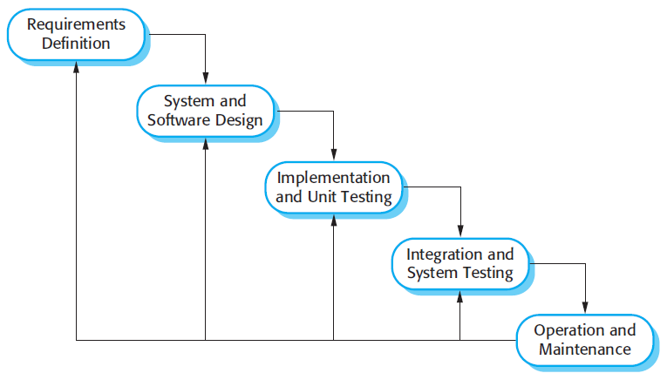

*Figure 1*

**2.2 Organizational Structure**

* Lead Developer: Abdulsalam
* Software Developers: Kevin, William, Jae
* Abdulsalam: Leader, coder, supervisor, server owner, writer
* Kevin: Coder, worker, writer
* William: Coder, worker, writer
* Jae: Coder, Worker, writer

**2.3 Organizational Boundaries and Interfaces**

* The customer organization will be allowed to:
  + Create accounts
  + Create, edit, share, and delete files inside of their respective folders
* The parent organization will be allowed to:
  + Manage and maintain server, user interfaces, and code
  + Manage and delete files/accounts
  + Manage storage of server
  + Manage permissions of certain users

**2.4 Project Responsibilities**

* Front-end developers: Abdulsalam, Will, Kevin, Jae
* Back-end developers: Abdulsalam, Will, Kevin, Jae

**3. Managerial Process**

The main objectives of the software project are for each developer to contribute to building and coding the user/web interface and create a working and reliable cloud drive for people to use. The first main priority is to finish setting up the LEMP stack in order to have a basis for our programming.

**3.1 Management Objectives and Priorities**

The objectives of this project is to be as cost effective and as time effective as possible. In order to report the progress, the SRS, SPMP, and github pages will be updated after the completion of each phase. The group will be using NginX and other softwares to create a functioning server, we will be using these software to modify into a cloud drive so that we can save money. Our goal is to spend $0 and create a working cloud drive. Some of the risks involved with cloud drive is the amount of space that will be allocated for the users in the server.

**3.2 Assumptions, Dependencies, and Constraints**

* The constraints of this project when it will be conducted is that there will only be a limited amount of users that can make accounts since storage is limited to around 200 gigabytes of storage.
* This project is dependent upon actual users because customers need to make accounts in order to fully utilize everything in the system.

**3.3 Risk Management**

* An abundance of inactive users leading to wasted storage.
* Server fails and the website becomes unusable for a period of time, making it so no customers can use the services provided by the system.
* The database is breached by intrusive hackers and user information can be stolen.
* There could be trouble at each step of installing the LEMP stack.
* There could be lashback on the quality of the product from a user standpoint.

**3.4 Monitoring and Controlling Mechanisms**

* PuTTY will be used in order to monitor everyone working on the project to ensure that everyone is putting in an equal amount of effort.

**4. Technical Process**

* For hosting and running the server, the Ubuntu linux OS will be used
* For hosting the user interfaces and the website, PHP will be used
* For hosting the database, SQL will be used
* NginX will be used to transfer UIs over to the website

**4.1 Methods, Tools, and Techniques**

The system that is being used to host the server is Ubuntu linux 20.04, however, using a program called Putty, we will be able to code from our own computers. Some of us are using a Windows operating system to code and some of us are using Mac OS. The development methodology will consist of us working together on the same components until we get to the user interface phase. Once we are at that step, the work will be split amongst us. We will be using SQL for the database, Javascript and PHP for the website, and a LEMP stack for the server.

LEMP stack:

This starts with us using Linux as a base for our server. Nginx will be the first to be installed on this OS. Nginx is a high performance web server. Using Nginx, users will be able to actually see the web pages that they need. After Ngnix is installed, we will need to update the firewall rules to allow access to it from anywhere. This would include any HTTP traffic on the internet. The next step would be setting up MySQL to build our website’s database. After this, we will set up PHP for the application. PHP will be the bridge from what people use to interact and the Ngnix web server. It will also be able to connect to MySQL and retrieve/store information. Then Nginx will need to be configured to use the PHP processor. After the LEMP stack is all finished, we will start developing the web page in which the user will see. The page should look something like this:

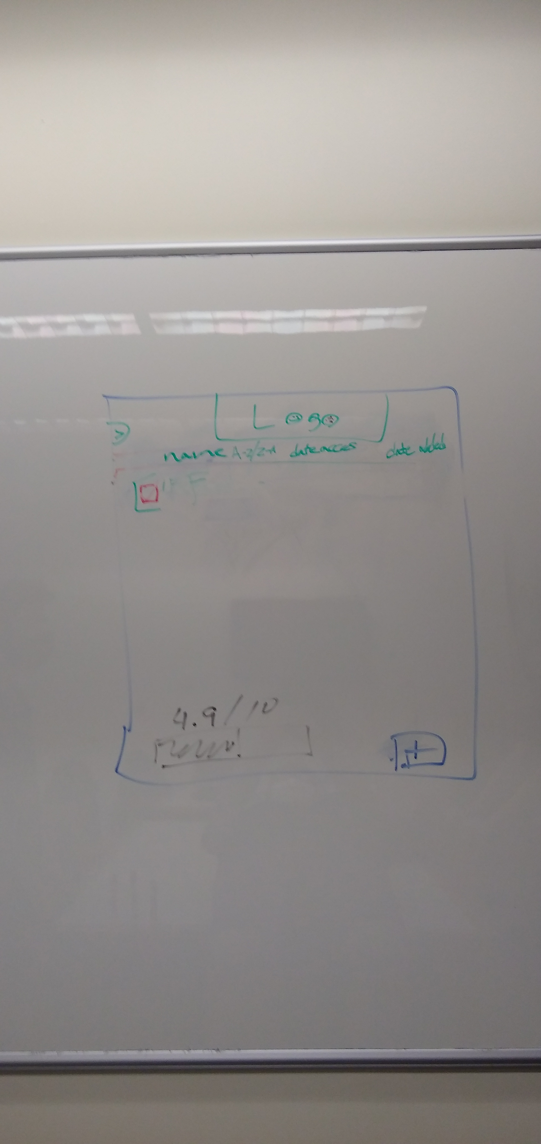

During the final phase of development, we will be focusing mainly on testing to make sure the website works reasonably well. We may also involve other people in the testing stage to ensure quality.

**4.2 Software Documentation**

* In order to keep track of all the milestones, Github will be used to document all coding aspects of the project. SRS and SPMP documents will be updated as the project progresses through the various phases.

**4.3 Project Support Functions**

There will be no additional software other than the specified pieces of software needed to get the project working in order for either validation or quality assurance. It is planned for developers and programmers to validate their programs after each phase of the process model to ensure that everything is working according to plan.

**5. Work Packages, Schedule, and Budget**

The work packages of this project include

* Development of the UI
* Development of the website
* Development of the Server
* Development of the database

There is no planned schedule for work packages

For the project, we aim to spend 0 dollars, but have a maximum budget of 40 dollars if necessary (to host the server)

**5.1 Work Packages**

* Sign in, Login Screen
* Buttons for editing: Delete, Share, Upload, Download
* User Interface: Settings, Organization
* Database
* Server
* Website

**5.2 Dependencies**

* Testing of the software cannot begin until the code is near complete
* Testing of the server cannot begin until server is made and hosted on a computer
* Sign in and Login depends on Website
* Website depends on the existence of the server
* Database depends on Server
* Buttons for editing depends on User interface

**5.3 Resource Requirements**

This software project is fairly resource friendly, as in the main physical resource needed is a computer to host the server. As far as software resources go, we need Nginx, MySQL, and PHP. We also need linux for the OS. We will need lots of access to computers. We will also reserve access in a room in the library at Eastern Connecticut State University to meet once a week and discuss our next tasks to further development. Computer hardware does not need to be much. As long as we can run the server without issues, we will be fine in conducting this project.

**5.4 Budget and Resource Allocation**

As stated above, the aim is to spend 0 dollars. If money has to be spent, all of the budget will be allocated to hosting and keeping the server up to keep our services running.

**5.5 Schedule**

Each phase should take around 2 weeks to complete and validate, up until the release of the product. Then after the remainder of the semester will be used to maintain the server and code for any possible bugs found in the later phases.